Installing OpenCV on Windows for C++

Visual Studio Yükle (community-topluluk versiyonu)

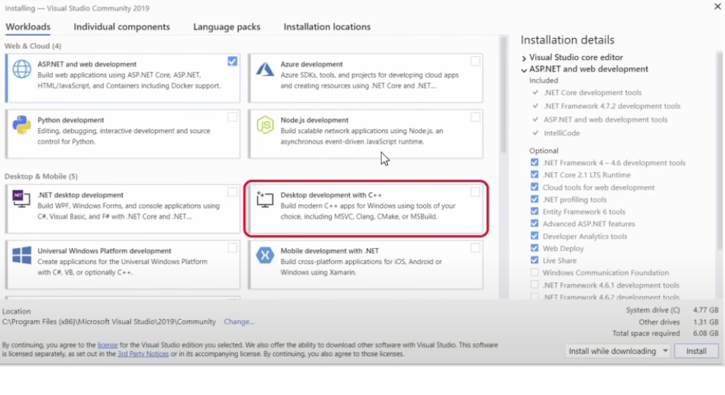

Step 1

Go to <https://github.com/opencv/opencv> and download the Lastest Release

Extract Files to local drive e.g. D:

# Step 2

Add bin folder to the Environment Variables path (sistem ortam değişkenlerini düzenleyin)

D:\opencv\build\x64\vc16\bin

# Step 3

Create a New Visual Studio project C++ console.

Set the platform target to x64

Step 4

Add Directories by going to Project-Properties-Configuration Properties-

VC++ Directories

1. Add Build Directories: D:opencvbuildinclude

2. Add Library Directories: D:opencvbuildx64vc16lib

Linker Input

3. Add Linker input: opencv_world490d.lib

d for debug without d for release

# Step 5

Run test code. First add the lena image to the Source Files

In this example the image is placed in a new folder by the name Resources therefore the path is “Resources/test.png”

#include <opencv2/imgcodecs.hpp>

#include <opencv2/highgui.hpp>

#include <opencv2/imgproc.hpp>

#include <iostream>

using namespace cv;

using namespace std;

///////////////// Images //////////////////////

void main() {

string path = "Resources/test.png";

Mat img = imread(path);

imshow("Image", img);

waitKey(0);

}